Tyler McKean

Nov 1st, 2020

ENGIN 435 – Antenna Design

Project 2: How It Works

The second project of the semester involved designing and modeling different smallish antennas and how their design parameters allow them to function optimally. When selecting an operating frequency for the antenna, perhaps the most important parameter that contributes to the design process is the wavelength. Designing the antenna structure such that it accommodates a certain ratio of the wavelength will allow the antenna to radiate efficiently, otherwise, there may be a mismatch in the structure where the antenna can not operate at full capacity. The project asked us to model four different smallish antenna structures: dipole, monopole, loop antenna, and normal mode helix antenna. To model and simulate how these antennas radiate, I used an electromagnetic simulation software environment called FEKO, where I could change structural parameters and then export the results into MATLAB, where I plotted my results for easy comparison. Since we are using the student edition of FEKO, our simulation capabilities were quite limited. So, for most of this project, we were asked to simulate these smallish antennas around an operating frequency of 300MHz and investigate how several parameters like the current distribution on the antenna, the real and imaginary impedances varying across frequency, and the radiation patterns all change when the physical model is scaled in size. Not all antennas behaved in comparison to this scaling process, so I will elaborate on how each of these antenna structures reacted to this process and provide graphs and animations to further the examination in better detail.

The most popular and widely used antenna out of the set is the dipole. The dipole consists of two conducting elements, such as simple pieces of wire, of which the current flows in the same direction at each node at the ends of the wire, which allows it to radiate. For this project, we were asked to model an electric dipole made from a PEC material and vary the dipole’s length from 0.1 meters to 0.7 meters at a resonant frequency of 300 MHz. We were asked to either make an animation or provide a 2D graph of the current distribution vs length, of which I chose the latter for this antenna but made animations for the others. The graph for current vs length can be seen in Figure 1 below.

Figure 1 - Current distribution on a dipole @ 300MHz as the length is varied from 0.1m to 0.7m

When stimulating the varying lengths of the dipole in FEKO, the EM software broke up the model into segments ranging from 5 segments at a length equal to 0.1m and 15 segments at a length equal to 0.7m. It is important to note that the feed point for the antenna was placed exactly in the center of the resonant structure for each simulation. The operating frequency of the dipole is at 300MHz which means that the corresponding wavelength would be the speed of light divided by 300MHz equaling lambda being 1 meter. So, the dipole length simulations run from about one-tenth of a wavelength to about seven-tenths of a wavelength. When the length was equal to 0.5m, the dipole was then modeled as a half-wavelength dipole and had a maximum current value of about 11mA based on Figure 1 traces. This is because each conductive element on either side of the feed point was oriented as a quarter wavelength and the currents on each side are perfectly in phase and experienced constructive interference. So, the currents are oscillating up and down in unison, which allows the structure to radiate at its maximum. For lengths above and below 0.5m, the dipole has similar characteristics to transmission line theory; if the dipole’s length was the same as the wavelength, 1m, a current minimum would occur at the feed point at the center of the structure and look like an open circuit, thus no power could be delivered and the structure would not radiate. From Figure 1, the lengths 0.6m and 0.7m are approaching a dip at the center of the current distribution, which would occur if I simulated up to a length equaling 1m. Half-wavelength antenna orientation is then seen as a short circuit, in comparison, because the antenna can drive its maximum current with the least amount of input impedance.

Figures 2a & 2b – Real and Imaginary Impedances of Dipole @ 100MHz to 500MHz with lengths vaired from 0.1m to 0.7m

The plots for the real and imaginary impedances of the dipole can be seen in Figures 2a & 2b above and display these transmission line theory characteristics. In the real impedance plots, the impedances resemble shapes close to a Gaussian pulse as they exponentially grow to a maximum and decay back down to zero. For lengths 0.6m and 0.7m, the impedance shapes are approaching the resonant frequency from the right and if the simulation was taken at a length equal to 1m, the Gaussian-like shape would be centered at 300MHz. This is the open circuit phenomenon I mentioned before, where the current minima would occur at the feed point and the input impedance would like it’s infinite, which is conveyed by the peak values in the resistance. When the dipole is at a half wavelength the real impedance looks to be somewhere around 70Ω, which is around the typical input resistance for a half-wavelength dipole. The imaginary impedance shown in Figure 2b is about j43Ω for when length equals 0.5m, which is around the typical value of j42.5 for a half-wavelength dipole. At lengths less than 0.5m, the imaginary impedance is purely capacitive, which is represented by the negative values at the start of the frequency sweep. The antenna is said to have zero reactance at lengths just slightly less than 0.5λ, so around 0.48λ the antenna would be at 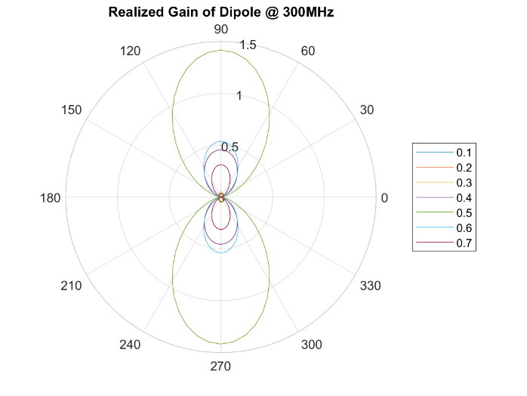resonance.

Figure 3a - Vertical Cuts of Dipole's Realized Gain @ 300MHz as the length is varied from 0.1m to 0.7m.

The dipole’s realized gain for each of the length variations can be seen in Figure 3a above. The realized gain is similar to the regular gain, which is the efficiency multiplied by the directivity, but realized gain has an additional factor called the matching efficiency that is multiplied by the Gain. This gives us a more realized perspective of the gain because the simulation software will account for a near-perfect efficiency that is multiplied by the directivity, so the matching efficiency will account for the mismatch of the wavelength to the physical lengths of the antenna. This is why the value of 0.5m has the highest value in the polar plot because the antenna is modeled as a half-wavelength dipole and has the highest matching efficiency compared to lengths above and below 0.5m. The Broadside Realized Gain of the Dipole can be seen in Figure 3b below. The plots show the maximum realized gain for each length variation and these maximums are decreasing in frequency when the length is increased. The curves also tend to be wider for the shorter values of length than the larger values. The trace for 0.5m would make this dipole a half wavelength and shows the maximum occurring around 300MHz. Again, this plot confirms that the better matched the antenna structure is to the wavelength, the stronger and wider realized gain will be centered around that antenna’s operating frequency.

Figure b - Broadside Realized Gain of Dipole @ 300MHz as length varied from 0.1m to 0.7m

The second antenna structure we were asked to model and simulate was a Monopole, which is very similar to a dipole. The monopole is a single conductive element, such as a rod or wire, but is perpendicularly mounted to a conductive ground plane. The feed point is attached to the lower end of the monopole close to the ground plane. This antenna will only radiate about half the power of the dipole since the structure is half that of a dipole and can only radiate above the ground plane. A phenomenon called Image Theory impacts this antenna structure, which states that at the boundary of the ground plane, the fields should be zero and no radiation can occur below it. If the ground plane could go off towards infinity this monopole would have a similar radiation pattern to a dipole, because the upper radiation of the monopole would be reflected from the ground plane and form the lower half of a dipole’s radiation. In Figure 4 below, an animation of the current distribution on the monopole and ground plane is shown. This animation shows the ground plane being varied from 0.1m by 0.1m to 2m by 2m, and at every step as the length is increased the ground plane has a surface current value of 0 A/m. The monopole itself seems to have a current max when the ground plane is 0.5m by 0.5m which would orient the wire and ground plane at a perfect quarter wavelength for the operating frequency of 300MHz. Once this dimension is passed the currents on both the monopole and ground plane continue to reduce in values, which indicates that the structure is approaching an open circuit with a very high impedance. Since the monopole will only radiate half the power of the dipole it also has half the value in impedance of the dipole too. When the monopole is modeled at a quarter wavelength the expected value for the impedance is about 36.5 + j21.25Ω.

Figure 4 - Current Distribution animation of Monopole @ 300 MHz as ground plane is varied from 0.1m x 0.1m to 2m x 2m

Looking at Figures 5a & 5b, the values around 300MHz appear to be close to 40Ω for the real impedance and around j20Ω for the reactance in the imaginary impedance plot. I found that the ground plane variations did not vary the impedances as both the real and imaginary values are all closely traced to each other, except at the starting value of 0.1m by 0.1m.

Figures 5a & 5b - Real and Imaginary Impedances of Monopole from 100MHz to 500MHz as ground plane is varied from 0.1m x 0.1m to 2m x 2m

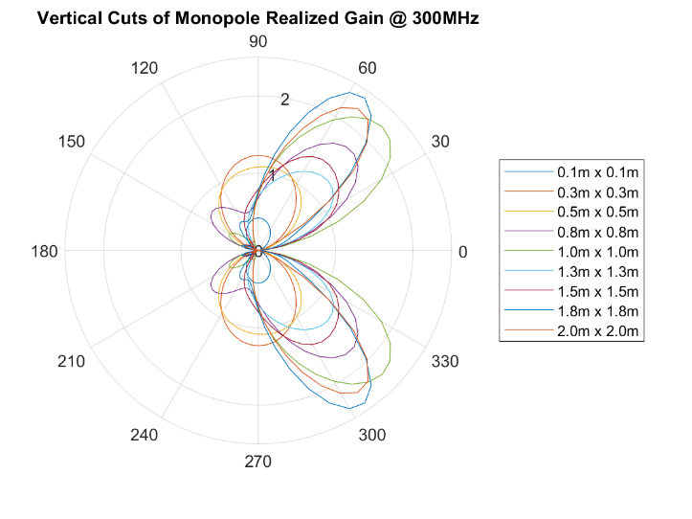

Figure 6 - Vertical Cuts of Monopole's Realized Gain @ 300MHz as ground plane is varied from 0.1m x 0.1m to 2m x 2m

The biggest observation I noticed when varying the ground plane was the radiation pattern shifted from a horizontal orientation and tilted towards a vertical orientation as the ground plane increased in the area. The pattern changes can be seen in Figure 6 above, which shows a polar plot of the realized gain as the ground plane is increased from 0.1m by 0.1m to 2m by 2m. The pattern is shown to have a figure eight shape at the lower values and gradually takes on a butterfly-like shape for the latter set of ground plane values. Comparing the realized gain plots of the monopole to the dipole, the monopole max gain values are double the max values of the dipole. The directivity of the monopole is doubled because no radiation occurs below the ground plane, and this effectively increases the directivity.

The next antenna structure I modeled in FEKO was a loop antenna with parasitic loading. This structure had a piece of conductive wire wrapped around a rectangular piece of metal inside the loop with a varying gap between the wire and metal. The feed point for the antenna was placed in the center of the bottom wire while keeping the circumference of the wire constant. Shrinking the metal rectangle inside the loop, I varied the gap between the wire and the metal plate from 5mm to 2.5cm. A varied-gap current distribution animation can be seen below in Figure 7. The circumference of the wire around the metal rectangle was 1m, which is an exact wavelength for the operating frequency of 300MHz.

Figure 7 - Current Distribution animation of Loop antenna @ 300MHz with the gap varied from 5mm to 2.5cm

Observing the animation, I noticed the currents only decreased on both the wire and metal rectangle as the gap between the two increased. So, the smaller the gap between the metal plate and the wire, the higher the current was on both conductive materials. As the plate’s area approaches zero, the loop wire would just have a constant current across it that would be smaller than having the plate inside of it. I assume the role of the plate is to increase the antenna’s directivity similar to how the ground plane of the monopole increased its gain and directivity. Since the radiation pattern for loop antennas is in the plane of the antenna itself, image theory would be a contributor to increasing the gain on both sides of the metal plate by directing the lobes more perpendicular in the plane of the metal plate. I assume that the larger the metal plate is the higher the gain for the radiation pattern would be. The real and imaginary impedances of the loop antenna can be seen in Figures

8a and 8b below. The real impedance of this antenna was very low, which makes the loop antenna look somewhat like a short circuit since the real impedance is very close to zero. The values for the real impedance ranged from about 16-72Ω, which made the loop antenna have an impedance similar to the monopole or dipole depending on how large the metal plate was inside the loop. Also, all the different gap sizes resulted in a similar impedance spike around 450MHz, which looked like an open circuit at the feed point.

Figure 8a & 8b - Real and Imaginary Impedance of Loop Antenna @ 300 MHz as gap is varied from 1cm to 7cm

The imaginary impedances around 300MHz had values ranging from -j105 to j22Ω. So, depending on the size of the plate the imaginary impedance was capacitive for the larger values of the gap and inductive when the gap was at its smallest value. The imaginary impedance had high inductive resistance of around 150MHz and high capacitive resistance of around 450MHz. These spikes occurred at ½ and 3/2 of the 300MHz mark, which I believe are the effects of the wavelength being too large for this 1m circumference and having a large inductive resistance. If the wavelength was too small for this structure, then the impedance would look like a purely real open circuit.

Figure 9 - Vertical Cuts of Loop Antenna's Realized Gain @ 300MHz as the gap is varied from 1cm to 7cm

A polar plot of the loop antenna’s realized gain can be seen above in Figure 9 and it shows a group of figure-eight patterns for each of the gap variations. The lowest gap value on the plot is the 2cm pattern and it appears to be the only value that produced a symmetrical shape out of all the gap variations. The other values produced an asymmetrical shape with the back lobe being slightly larger and having a wider beamwidth. I suspect this is a characteristic of the loop antenna being altered by the metal plate. The plate seems to be making the gain more unidirectional in the back lobe rather than equal on each side of the plane that the metal plate is within.

The final structure I modeled in FEKO was a normal mode helix antenna and was tasked with changing the spacing in between the coils and observing how these parameter changes affected the antenna’s behavior. This antenna has a conducting wire wound in a helical shape and is connected to a ground plane with a feed point at the bottom of the wire close to the ground plane. To change the spacing between the coils while keeping the circumference unchanged, I altered the “frac” variable from 0.05 to 0.2, which spaced the coils from 1.4mm to 2.8mm. Before simulating, I speculated that this antenna would behave similarly to the monopole since both are just structures of conductive wire mounted perpendicularly to a conductive ground plane. I expected to see a radiation pattern and current distribution similar to both the monopole and dipole. An animation of the current distribution for each variation of the spacing can be seen in Figure 10 below. The biggest observation from the current distribution I observed was that the current on the coiled wire only increased when the spacings between the coils increased. The surface current on the ground plane also increased but only in the small area close to the feed point on the ground plane. I assume that image theory would comparably factor into this antenna and would give this antenna a bit more directivity because the coiled wire is mounted to the ground plane.

Figure 10 - Current Distribution for Helix Antenna @ 300MHz with spacing between turns varied 1.4mm-2.8mm

However, I was surprised after simulating this structure and observing the far-field radiation in POSTFEKO. This antenna has an omnidirectional radiation pattern that is similar to a dipole. I thought that the ground plane of the helix would alter the pattern and make it a more vertically polarized radiation pattern that would extend along the axis of the coil. Both the real and imaginary impedances had consistent traces when plotted versus frequency, seen in Figures 11a and 11b below. Both the real and imaginary traces increased when the spacing between the coils increased. Comparing this to the dipole, I noticed the helix antenna also has an impedance that looks like an open circuit if the wavelength is not factored into the construction parameters of this antenna. I think maybe the spacing intervals I chose for this simulation were not large enough to gather any significant difference between simulations. The real impedances seem very low and are almost considered a short circuit, while the imaginary impedances are capacitive around 300MHz. Since the wire is coiled around the z-axis, I would have assumed the imaginary impedance to be more inductive.

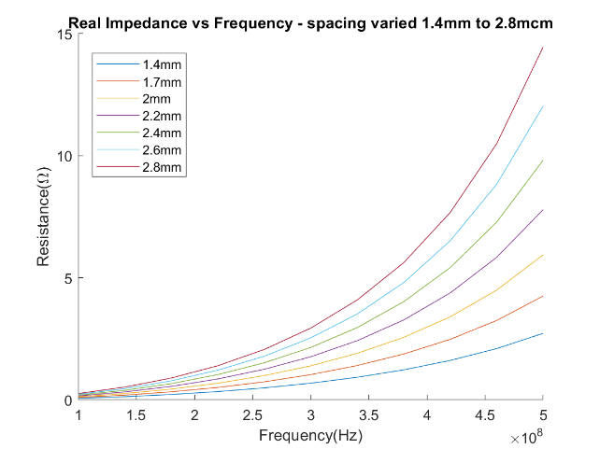

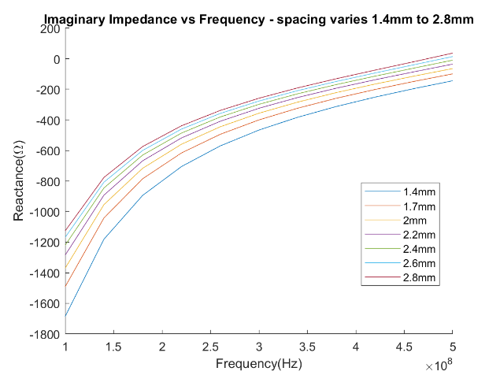

Figure 11a & 11b - Real and Imaginary Impedance of Helix Antenna @ 300MHz with spacing varied 1.4mm to 2.8mm

I noticed a similar trend when plotting the vertical cuts of the helix antenna’s realized gain, which is shown in Figure 12 on the next page. The realized gains of the antenna increased in a linear pattern when the spacing between the coils was increased. I assume the realized gains increased with each spacing succession because the matching efficiency for the antenna was approaching 100%. Again, I think my spacing intervals were too small to see a similar trend that exists in transmission line theory, where if the antenna structure is unmatched by the wavelength, the antenna’s behavior would react like a short circuit, open circuit, or be perfectly matched.

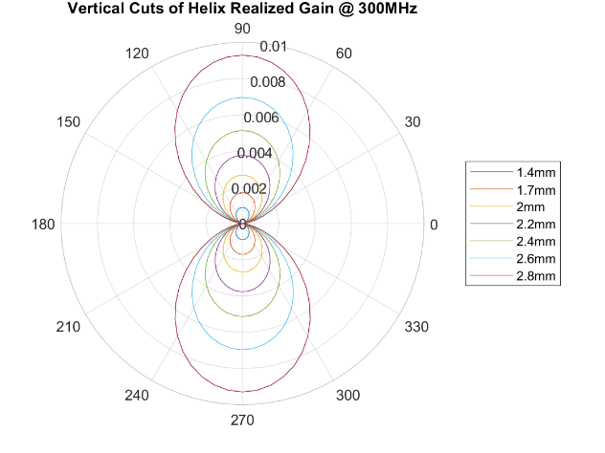

Figure 12 - Vertical Cuts of Helix Antenna's Realized Gain @ 300MHz with spacing varied 1.4mm to 2.8mm

The design and construction of smallish antennas are heavily dependent on the wavelength. Through my simulations and plotting of data, I found that most of these antennas follow the same requirements of transmission line theory, where the antenna’s radiation, realized gain, and impedances are vastly dependent on how well-matched the structure is to the operating frequency and wavelength. It was also beneficial to gain experience with electromagnetic simulation software such as FEKO, to be able to familiarize myself with the behaviors of these different types of basic antennas. These basic antenna types each serve their purpose depending on their transmitting and receiving application and need to be designed as perfectly matched to the wavelength to operate in the most efficient way possible.